Good evening, everyone! I have seen everyone discussing the development of the Indian stock market in the last couple of days. I would like to talk to you about this aspect as well, and hope that it will help you in your future for your trading needs
Alright, so let's begin with tonight's topic. Everyone, please stay attentive and make the most of it
On 23rd May 2024, we witnessed the Indian stock market reach the historic $5 trillion market cap milestone. The BSE market cap was $5.05 trillion with a total of 173 million investors. There are only three countries in the MCAP club with a market capitalization of more than $5 trillion - the USA, China, and Japan. With a market capitalization of nearly $60 trillion, the US is by far the world's largest stock market. It is closely followed by China ($10.1 trillion) and Japan ($6.5 trillion). Our Indian stock market has retraced from 27th September 2024 and though it has retraced close to 14% of its market capitalization so far, it still has $4.1 trillion left in it now, so are you outperforming the broader market in terms of returns and have you found your place in this frenzy, we need to understand the rules of the game in the Indian market and the mysteries of the long term upswing and by understanding the market's macro and fundamentals to find out what the market is telling us.
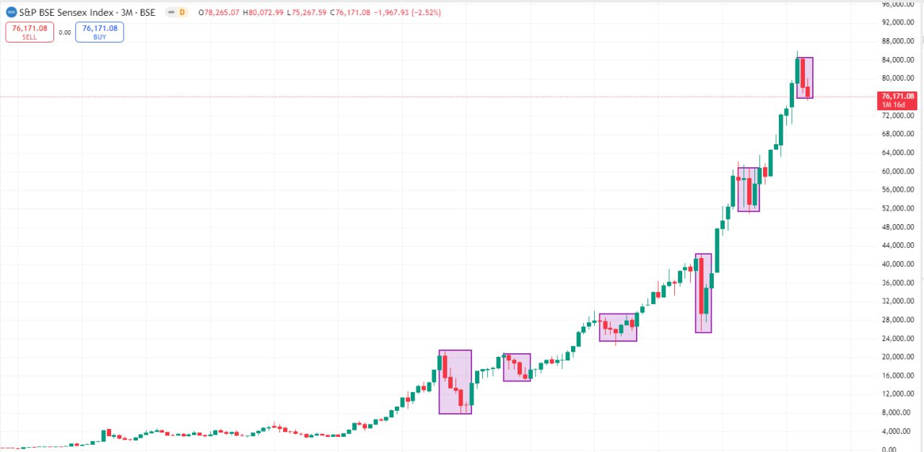
India's stock market opened to the outside world a long time ago, foreign investors hold a lot of the market value of the Indian stock market, SENSEX is an important reference indicator for investing in the Indian market, the Bombay Stock Exchange has a long history of 150 years of trading history, is a completely European and American typical stock market, 20 years showing a 20-fold trend!
Similarly, in recent years, there have been several ups and downs, such as the global financial crisis in 2008, the struggling economies of Europe and the US in 2010, the low global growth from July 2014 to September 2015, the impact of the new COVID-19 epidemic in 2020, etc., in addition to which the Mumbai SENSEX 30 has risen sharply. The current P/E ratio of SENSEX is also at an all-time high, with valuations higher than the uniformity faced by the global stock markets, which are included in the SENSEX, for example, software companies, FMCG companies, banking stocks, etc.. The higher valuations of Indian equities are mainly rooted in the stage that India is in, and the current stage of development in the Indian economy is one of emerging industry development, which is growing very fast, and the natural growth of the business is also the natural growth rate of the companies, which is also very fast!
India's market capitalization has seen a surge of more than 60% from its March 2023 lows, a growth driven by the rise in shares of small and medium-sized companies. In addition, the country's stock market has been supported in recent years by blood transfusions from newly listed large companies. For example, Life Insurance Corporation of India, which went public two years ago, had a recent market capitalization of $78.9 billion. Apart from life insurance companies, the market capitalization of public sector undertakings (PSUs) as a whole has increased significantly over the past year. India now boasts of 100 stocks with a market capitalization of over $10 billion, compared to 30 before the epidemic.
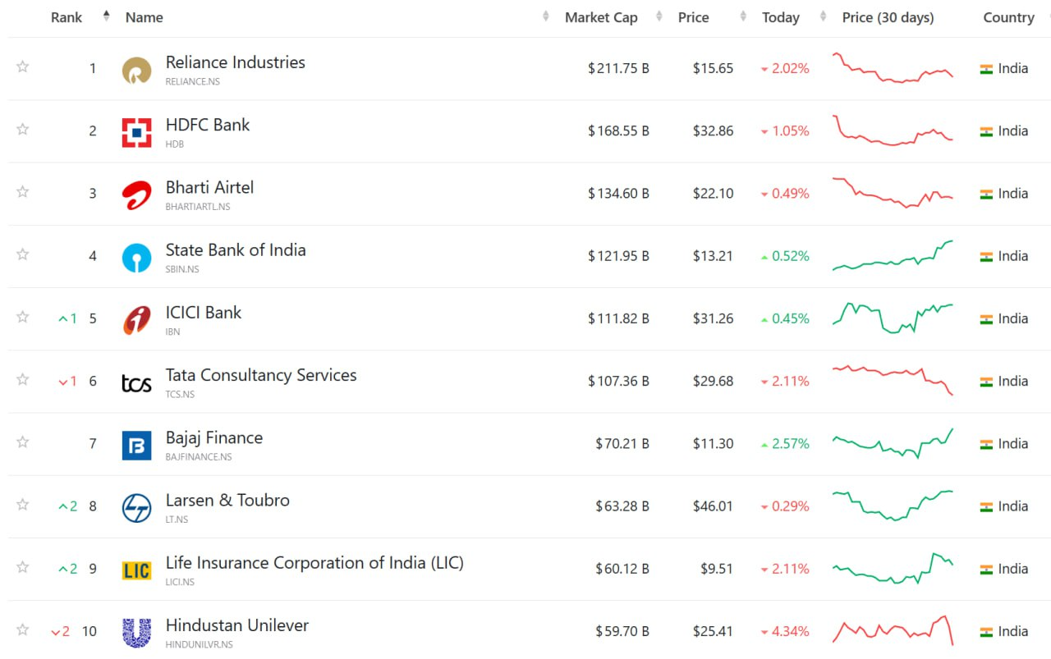
Currently, Reliance Industries remains the highest market capitalization company in India, followed by HDFC Bank, Bharti Airtel, State Bank of India, ICICI Bank, Tata Consultancy Services, Bajaj Finance , Larsen & Toubro, Life Insurance Corporation of India and Hindustan Unilever.
A decade ago, India was the 10th largest economy with a GDP of $ 2.1 trillion. Despite facing macroeconomic imbalances and a weak financial sector, it has climbed to 4th place with a GDP close to $ 4.27 trillion. Over the past three years, the Indian economy has been growing at over 7% per annum, driven by strong domestic demand.
Currently, Reliance Industries remains the highest market capitalization company in India, followed by HDFC Bank, Bharti Airtel, State Bank of India, ICICI Bank, Tata Consultancy Services, Bajaj Finance , Larsen & Toubro, Life Insurance Corporation of India and Hindustan Unilever.
Another feature of the Indian stock market, relative to a decade ago, has been a decline in foreign institutional ownership and an increase in domestic ownership. The data shows that foreign institutional holdings have declined from 19.13 percent to 16.51 percent, while the participation of small investors through individual accounts and mutual funds has increased.
India's young and vibrant population is increasingly participating in the stock market, leading to more investment inflows and sustained market growth. India is transforming itself from a savings nation to an investing nation, especially in recent years, investors have been entering the market especially through regular investment schemes (SIPs), which are growing in mutual funds, and the wealth management industry in India has now reached a global scale, with SIPs contributing to record highs, despite the recent decline in equity fund inflows.
According to the Association of Mutual Funds in India (AMFI), equity mutual funds attracted Rs 189.17 billion in April last year, down 16% from the previous month, mainly due to increased market volatility and pre-election caution. In fact, Indian equity funds have seen net inflows for the 38th consecutive month since March 2021. Although the pace of fund inflows has declined month-on-month recently, the contribution of monthly regular investment plans (SIPs) has exceeded the Rs. 200 billion mark, reaching a record high of Rs. 203.71 billion in April last year.
India is now the second-largest market in the MSCI Emerging Markets Index after China, with a weightage of nearly 19 percent, much higher than the 8.2 percent in 2018.
Being one of the fastest growing economies in the world, India is also one of the few emerging markets that are highly favored by overseas fund managers, however, the current valuation of the Indian market, as measured by the commonly used price-earnings (PE) ratios, currently stands at close to 24 times, which is 14-40 per cent higher than the average of the last five, 10 and 20 years. Small and mid-cap stocks are more overvalued relative to blue chips.
From 27 September last year till now, the SENSEX30 and NIFTY50 indices as a whole have retraced close to 14%, due to large-scale long-term outflows of FIIs, although short-term performance is not as good as markets such as the US and Japan. In terms of market performance, valuation, and lack of volatility, it may not be enough to attract overseas fund managers to return in a big way for the time being, but in the medium to long term, we have the Indian stock market, which remains the most promising and growing stock exchange.
SENSEX is a very European and American style of stock index compilation, through the continuous evolution of the regular inclusion and exclusion of the behavior, this behavior ensures that the constituents of the SENSEX have always been at the level of the best, let's take a look at the composition of the 30 constituents in the SENSEX at the moment, which is the fundamental reason why the SENSEX is in the upswing in the long term.
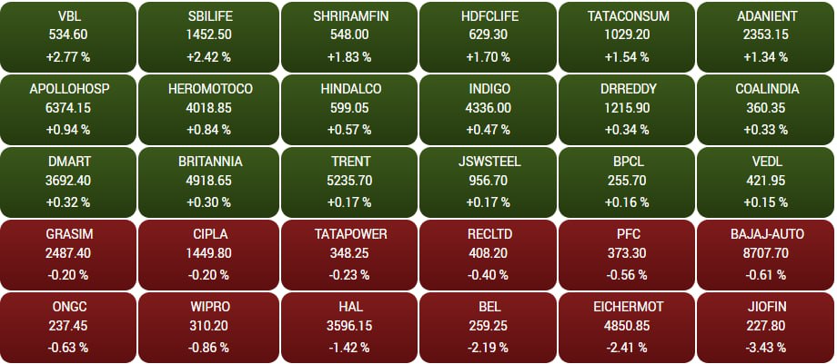
As shown by the data, foreign capital has bought a net of Rs 164 billion into the Indian stock market from early March to June 13 last year, which spawned a major bull market in the Indian stock market last year!
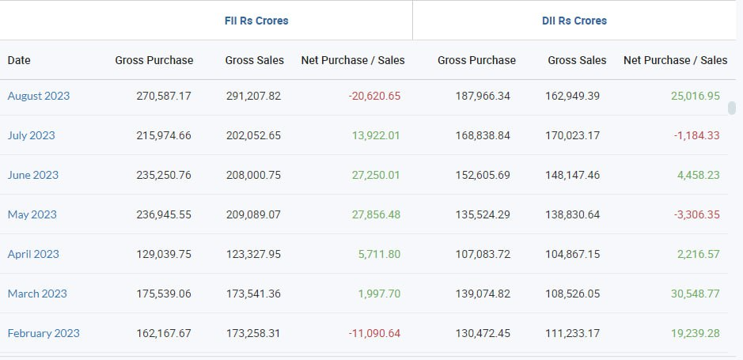
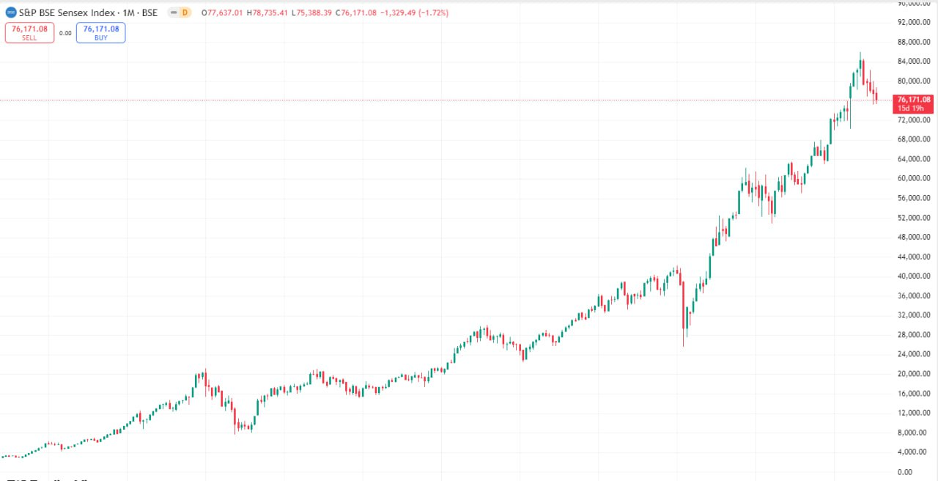
Stock market trading has never been more important than focusing on fundamentals! How does what I just said apply to stock market trading? This is what you need to learn, and going forward, I'm going to use this analysis to show you a few stocks to make them easier to understand.
In fact, I don't think any of the investment assumptions will change as a result of this outcome. If anything, in my view, it will only get better and bigger, and accelerated because the Prime Minister has said that in the next five years, I don't want to compare it with what we have done in the past, but think about how to keep India on the global stage. So it just suggests that there might be more vigor, more rigors, more aggressiveness, or a sense of urgency
So, in that sense, I think we're lucky. Other than that, I don't think my view of the India story has changed. The structural drivers of growth have changed. Whether it's manufacturing, whether it's infrastructure investment, strong banking and financial services growth, or consumption growth, none of these are at risk in my view.
The same is true of the push for infrastructure and the push for manufacturing. The Prime Minister has spoken many times about how we need to stand on our own two feet. So I think those policies will continue. Reforms will continue, particularly in some of the key areas, whether it's power, infrastructure or anywhere else, I think a lot of things are happening and maybe those reforms will continue, particularly one of the areas where I think the reforms may become more serious is power because if we don't address this in a meaningful way, India is going to have a shortage of power in a couple of years, so I think that power, thermal power and areas related to that are likely to get more attention because that is something that India needs very much.
In terms of infrastructure, there will be more changes in ports, there will be more changes in logistics, and I think that is a very, very critical need if India is to leapfrog. While I don't think it's a big issue, the focus may shift to the rural areas to improve productivity or to get more money in the hands of the farmers, and that may have some impact on the consumer side. I mean, anyway, the consumer story in India is still very much intact from a premium growth perspective, but there could be more dimensions to this. Other than that, I don't think there will be any major disruption from an economic perspective.
When it comes to trading, it's beneficial that you focus on the stocks we share in the afternoon every single day. Many members tend to buy stocks in the morning, while we typically disclose our recommendations later in the day. By the time the market is about to close, a stock has been traded for the entire day, allowing us to evaluate its performance in terms of daily volume, gains, and market interest. This approach can help us reduce trading risks and enhance our decision-making.

